# 影像處理期末作業

資工四1 1410432012 黃柏鈞

資工四1 1410432025 吳靚玹

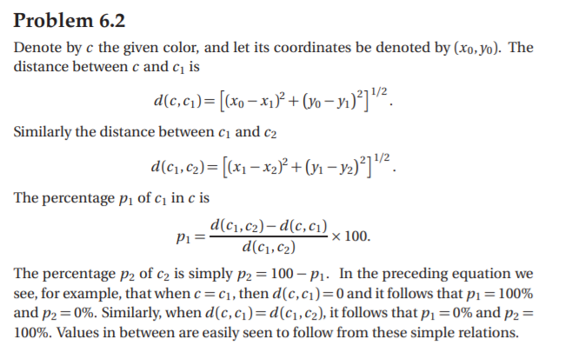

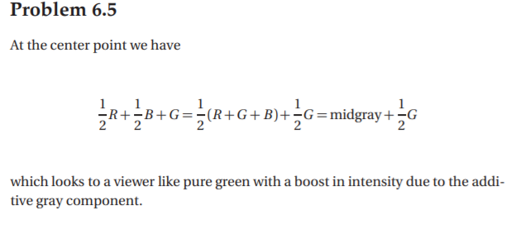

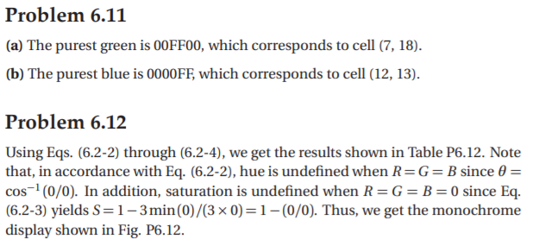

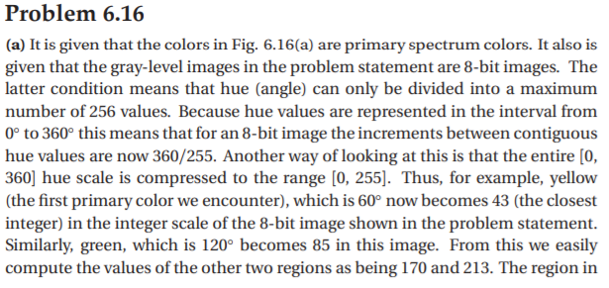

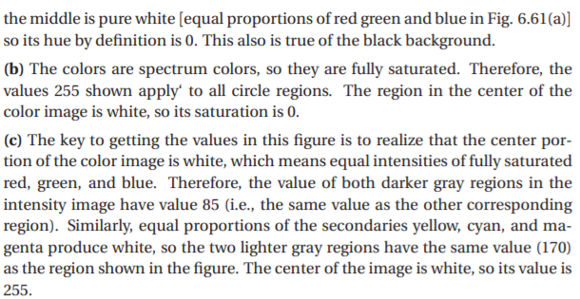

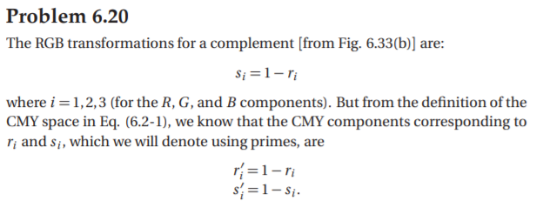

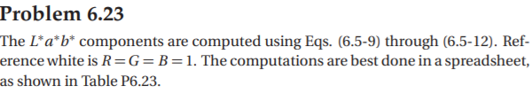

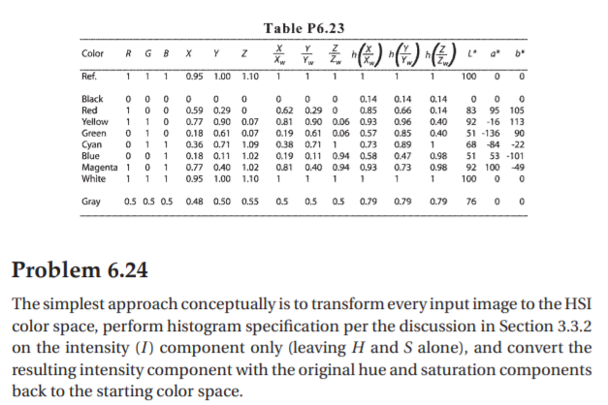

# 9. Web-Safe Colors (10%)

本題使用C/C++ 搭配OpenCV 3.4，並同步發表於本人部落格

程式碼連結:[**https://ppt.cc/fDyQNx**](https://ppt.cc/fDyQNx)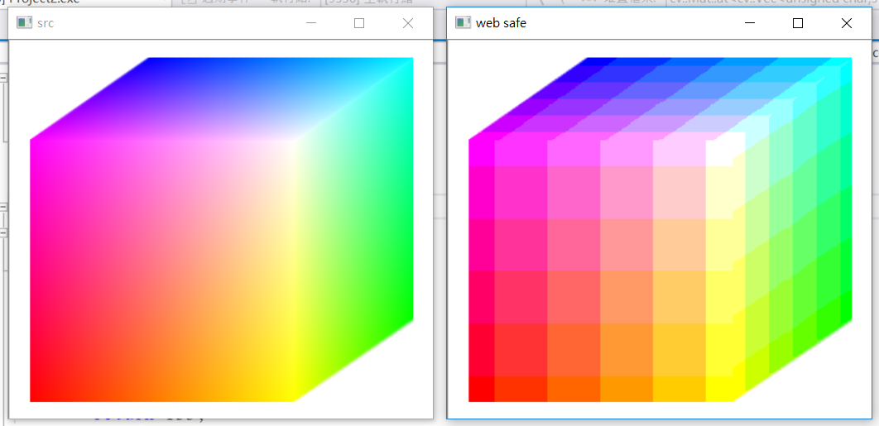

**說明:**

原圖具有上萬色(256^3色)需對應到Web-Safe色彩空間(216色)，抓出像素原始RGB值進行轉換convertToWebSafe(int color) ，上圖為一極端例子，轉換後由於Web-Safe色域較小導致出現方格

|  |
| --- |
| #include <iostream> |
|  | #include <opencv2/opencv.hpp> |
|  | #include <opencv2/highgui/highgui.hpp> |
|  | using namespace cv; |
|  |  |
|  | int convertToWebSafe(int color) { |
|  | //0 51 102 153 204 255 |
|  | // 25 76 127 178 229 |
|  | if (color >= 229) |
|  | return 255; |
|  | else if (color >= 178) |
|  | return 204; |
|  | else if (color >= 127) |
|  | return 153; |
|  | else if (color >= 76) |
|  | return 102; |
|  | else if (color >= 25) |
|  | return 51; |
|  | else |
|  | return 0; |
|  | } |
|  |  |
|  | int main() |
|  | { |
|  | Mat3b image= imread("C:/img/Fig0608(RGB-full-color-cube).tif");//image |
|  | Mat3b srcImage = imread("C:/img/Fig0608(RGB-full-color-cube).tif");//src image |
|  |  |
|  | int i, j; |
|  | int r, g, b; |
|  | printf("%d,%d",image.size().width, image.size().height); |
|  | for (i = 0; i < image.size().width;i++) { //access each pixel |
|  | for (j = 0; j < image.size().height;j++) { |
|  | b = image.at<cv::Vec3b>(j, i)[0]; //b |
|  | g = image.at<cv::Vec3b>(j, i)[1]; //g |
|  | r = image.at<cv::Vec3b>(j, i)[2]; //r |
|  |  |
|  | // |
|  | image.at<cv::Vec3b>(j, i)[0] = convertToWebSafe(b); |
|  | image.at<cv::Vec3b>(j, i)[1] = convertToWebSafe(g); |
|  | image.at<cv::Vec3b>(j, i)[2] = convertToWebSafe(r); |
|  | //printf("%d", image.at<cv::Vec3b>(j, i)[0]); |
|  | } |
|  | } |
|  |  |
|  | imshow("web safe", image); |
|  | imshow("src", srcImage); |
|  | waitKey(0); |
|  | return 0; |
|  | } |

# 10. Color Image Enhancement by Histogram Processing (10%)

本題使用C/C++ 搭配OpenCV 3.4，並同步發表於本人部落格

程式碼連結:[**https://ppt.cc/fqEkTx**](https://ppt.cc/fqEkTx)

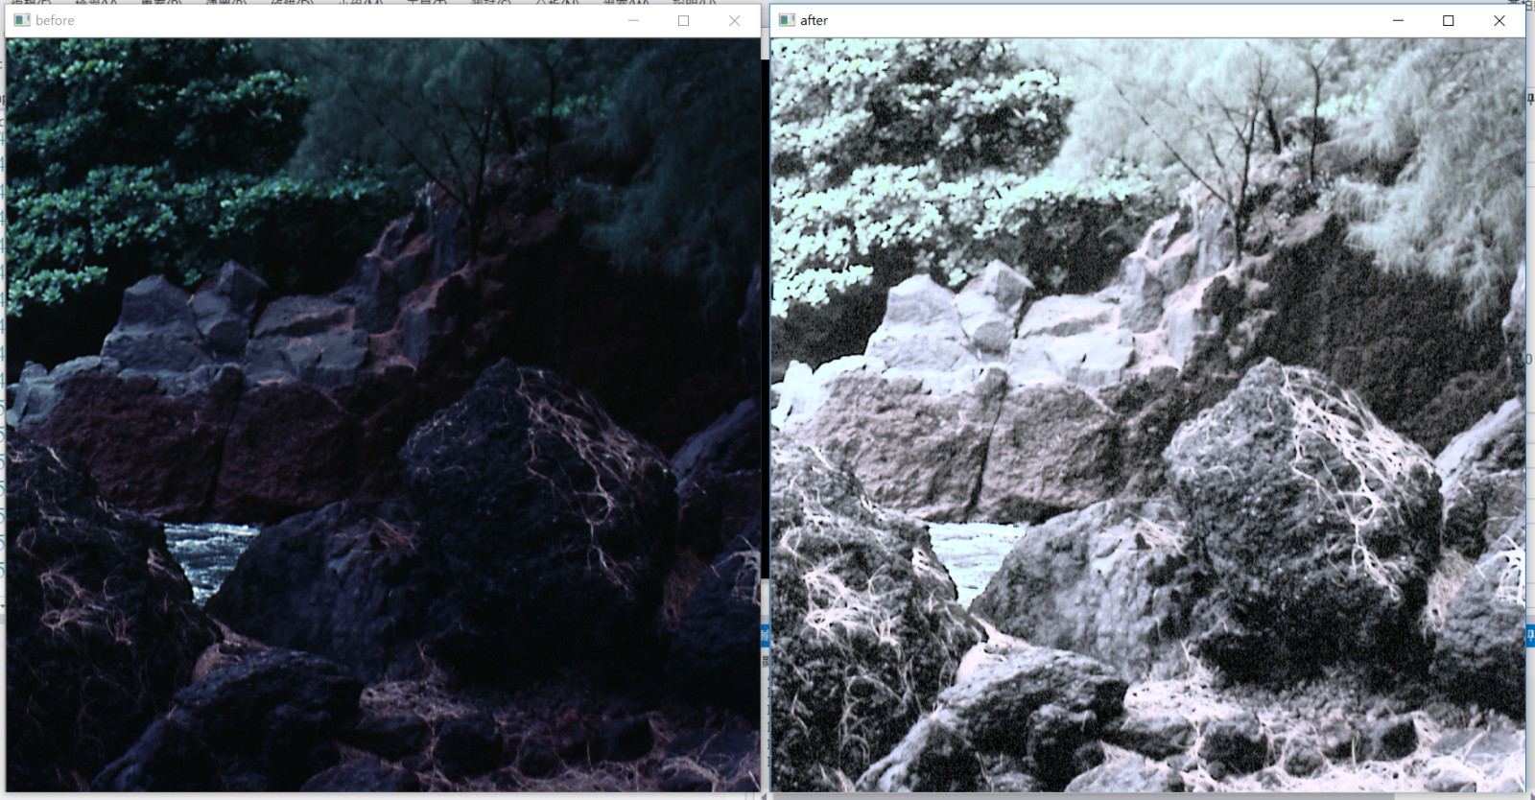

**說明:**

值方圖均衡化平均整張圖片的亮度，使得暗部空間的細節得以顯現

|  |
| --- |
| #include <stdio.h> |
|  | #include <iostream> |
|  | #include <opencv2/opencv.hpp> |
|  | #include <opencv2/highgui/highgui.hpp> |
|  |  |
|  | using namespace cv; |
|  | using namespace std; |
|  |  |
|  | /** @function main */ |
|  | Mat equalizeIntensity(const Mat& inputImage) |
|  | { |
|  | if (inputImage.channels() >= 3) |
|  | { |
|  | Mat ycrcb; |
|  |  |
|  | cvtColor(inputImage, ycrcb, CV_BGR2YCrCb); |
|  |  |
|  | vector<Mat> channels; |
|  | split(ycrcb, channels); |
|  |  |
|  | equalizeHist(channels[0], channels[0]); |
|  |  |
|  | Mat result; |
|  | merge(channels, ycrcb); |
|  |  |
|  | cvtColor(ycrcb, result, CV_YCrCb2BGR); |
|  |  |
|  | return result; |
|  | } |
|  | return Mat(); |
|  | } |
|  |  |
|  | int main(int argc, char** argv) |
|  | { |
|  | Mat src, dst; |
|  |  |
|  | /// Load image |
|  | src = imread("C:/img/Fig0635(bottom_left_stream).tif"); |
|  | Mat src2 = src.clone(); |
|  |  |
|  | if (!src.data) |
|  | { |
|  | cout << "Usage: ./Histogram_Demo <path_to_image>" << endl; |
|  | return -1; |
|  | } |
|  |  |
|  | src = equalizeIntensity(src); |
|  |  |
|  | imshow("before", src2); |
|  | imshow("after", src); |
|  |  |
|  | /// Wait until user exits the program |
|  | waitKey(0); |
|  |  |
|  | return 0; |
|  | } |

# 11. Pseudo-Color Image Processing (10%)

本題使用C/C++ 搭配OpenCV 3.4

程式碼連結:[**https://ppt.cc/f03Kdx**](https://ppt.cc/f03Kdx)

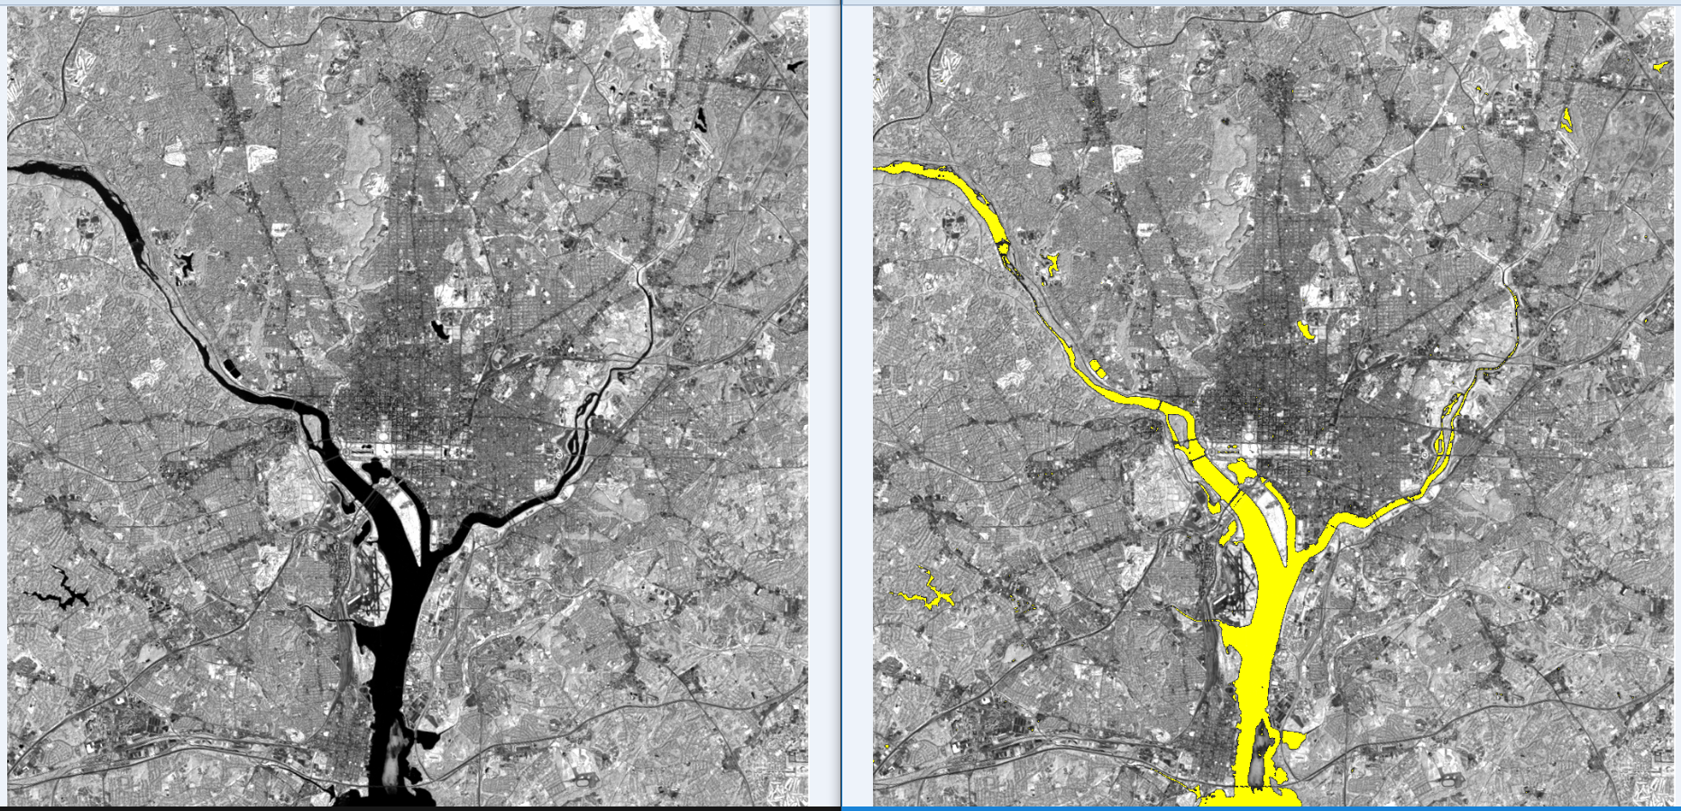

**說明:**

河流為深色區域，尋找顏色夠深的像素，將其替換成為黃色

|  |
| --- |
| #include <iostream> |
|  | #include <opencv2/opencv.hpp> |
|  | #include <opencv2/highgui/highgui.hpp> |
|  | using namespace cv; |
|  |  |
|  | int convertToWebSafe(int color) { |
|  | //0 51 102 153 204 255 |
|  | // 25 76 127 178 229 |
|  | if (color >= 229) |
|  | return 255; |
|  | else if (color >= 178) |
|  | return 204; |
|  | else if (color >= 127) |
|  | return 153; |
|  | else if (color >= 76) |
|  | return 102; |
|  | else if (color >= 25) |
|  | return 51; |
|  | else |
|  | return 0; |
|  | } |
|  |  |
|  | int main() |
|  | { |
|  | Mat3b srcImage = imread("C:/img/Fig0110(4)(WashingtonDC Band4).TIF");//src image |
|  | Mat3b image = srcImage.clone(); |
|  |  |
|  | int i, j; |
|  | int r, g, b; |
|  | printf("%d,%d", image.size().width, image.size().height); |
|  | for (i = 0; i < image.size().width; i++) { //access each pixel |
|  | for (j = 0; j < image.size().height; j++) { |
|  | b = image.at<cv::Vec3b>(j, i)[0]; //b |
|  | g = image.at<cv::Vec3b>(j, i)[1]; //g |
|  | r = image.at<cv::Vec3b>(j, i)[2]; //r |
|  |  |
|  | //find balck area rgb(0,0,0) ~ rgb(20,20,20) |
|  | int max = 20; |
|  | int min = 0; |
|  | if (b >= min && b<=max && g >= min && g <= max && r >= min && r <= max) { |
|  | r = 255; |
|  | g = 255; |
|  | } |
|  |  |
|  | image.at<cv::Vec3b>(j, i)[0] = b; |
|  | image.at<cv::Vec3b>(j, i)[1] = g; |
|  | image.at<cv::Vec3b>(j, i)[2] = r; |
|  | //printf("%d", image.at<cv::Vec3b>(j, i)[0]); |
|  | } |
|  | } |
|  |  |
|  | imshow("before", image); |
|  | imshow("src", srcImage); |
|  | imwrite("C:/img/Fig0110(4)(WashingtonDC Band4)_after.TIF", image); |
|  | waitKey(0); |
|  | return 0; |
|  | } |